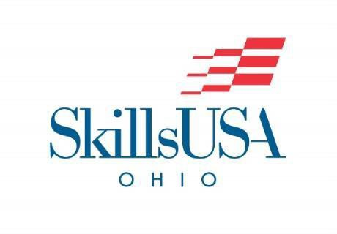
2024 Promotional Pin and T-Shirt Design Challenge
Official Submission Link: https://www.dropbox.com/request/uMOV98x95OcfGUvUwUg3
SkillsUSA Ohio is proud to announce the official Promotional Pin and T-Shirt Design Challenge.

The purpose of the challenge is to provide designs for a commemorative pin for the 2024 SkillsUSA Ohio State Championships and to provide a commemorative t-shirt design for the 2024 SkillsUSA Ohio State Championships. This pin will also be "the special pin" traded in limited quantities at Nationals.
(Note: These challengers do not compete at State or Nationals this is strictly a promotional design challenge)

Deadline – January 19 – Designs must be in the SkillsUSA Ohio Office by this date so they can be judged as in time to have them ordered for the Championships.
- Designs are limited to one per student
- Cash awards (for each challenge) 1 - First place - $200
2 - Second place - $100 3 - Third place - $50

Pin Requirements:
  - All entries must be rendered in color (full color or two color).
  - Preferably, entries will be created in a design software package such as Illustrator, Photoshop, Adobe etc.
  - All entries should be submitted with two versions of the art on a single page. The larger version is for judging. The smaller version is to show what the actual pin will look like. The larger version must be approximately 7 inches wide x 7 inches high for judging. The smaller version should be approximately 1 inch x 1 inch tall to show how the completed pin will look. Both versions should be identical. Wording on the pin must reference the name of the word SkillsUSA Ohio and must have the year displayed.
  - Do not use the official SkillsUSA logo or SkillsUSA emblem in the artwork.
  - Pin must include Year and the words SKILLSUSA OHIO
  - No copy-righted or proprietary branding may be used in the design usage of these will result in no judging and disqualification (i.e. block O, Script Ohio etc.)

T-Shirt Requirements:
  - All entries must be rendered in color (full color or two color).
  - Preferably, entries will be created in a design software package such as Illustrator, Photoshop, Adobe etc.

  - All entries should be submitted on a single page and not on a t-shirt diagram (All final T-shirt production color choices for ink and color of the shirt are in the sole discretion of SkillsUSA Ohio). Wording on the shirt must reference the name of SkillsUSA Ohio and must have the year displayed.
  - Do not use the official SkillsUSA logo or SkillsUSA emblem in the artwork.
  - Shirt must include Year and the words SKILLSUSA OHIO (SkillsUSA must be spelled correctly)
  - No copy-righted or proprietary branding may be used in the design usage of these will result in no judging and disqualification (i.e. block O, Script Ohio etc.)

- Judges' decisions are final.

- Artwork becomes the official property of SkillsUSA Ohio.

- Final Production Color Suggestions can be made but the final choice will be up to SkillsUSA Ohio

- Design Contest winners will be recognized during the SkillsUSA Ohio State Championships Awards Ceremony

- To submit Artwork:

ALL Artwork must be submitted through the following dropbox link:

https://www.dropbox.com/request/uMOV98x95OcfGUvUwUg3
- MAKE SURE THE STUDENT’S NAME AND SCHOOL IS SUBMITTED WITH THE DESIGN AND WHETHER THE ENTRY IS FOR THE PIN CHALLENGE, THE T-SHIRT CHALLENGE OR BOTH.

- USPS Mailed submissions will not be judged.

