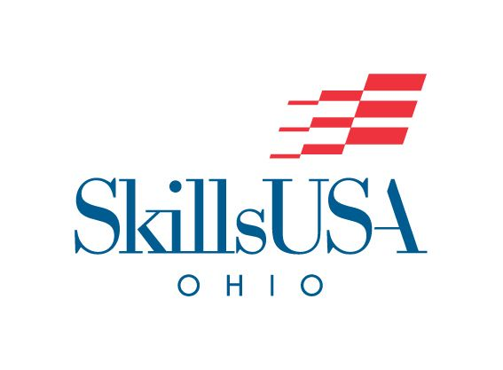

Medical Math

​To evaluate the students’ ability to understand and solve mathematical problems commonly used in the various health care settings.

On-Site/Off-Site | - On-Site
Contest Date | - ​5/5/2026
Contest Location | - Convention Center  - D284
Early/Normal  Start Time | - Normal Start Time  - Registration will open at 8:00am. Please report to B-Hall Show Office for Registration. Competition will begin at 10:00am.
Contest Open/Closed | - ​Closed  - This contest is closed to observers, instructors, and advisors.
Eligibility &  Contest Type | - Please refer to the Program Guidelines for eligibility- https://www.ohioskillsusa.org/resources/  - Regional Qualifier Contest (Must attend and place in the top 4 at Regionals to Qualify to Compete at State Level)
Clothing | For Competition Day the Dress Code is:  Class B  For the Awards Ceremony the Dress Code is: Class A or Class J  - SkillsUSA Ohio Clothing Guide
Safety Equipment Required | - N/A
Testing | - Students should be prepared to take a written knowledge test.
Provided by Contestant  (Tool List) | - 2 #2Pencils
Contest Notes, Themes, & Deadlines | - Calculators Provided
WIFI Provided? | - No
Special Notes/Rules for All Contests | - Starting in 2024, all Skilled Trade State Contests (most leadership contests already use scenarios) will begin to add a scenario-based component.  - Wi-Fi will NOT BE AVAILABLE unless listed above. If you need WIFI access, please plan to bring a hotspot.  - All safety requirements will be heavily enforced. Competitors are to follow all safety standards and OSHA Regulations  Contestants MUST HAVE A COPY OF THEIR EMERGENCY MEDICAL FORM IN THEIR NAME BADGE AT ALL TIMES  THE FOLLOWING ITEMS ARE PROHIBITED; VIOLATION OF ANY OF THE FOLLOWING MAY RESULT IN COMPETITOR DISQUALIFICATION:  - Contact with Contest Coordinators is prohibited.  - Contact with Contest Coordinators outside of the SkillsUSA Ohio is strictly prohibited.  - Possession of smart watches and/or phones during the contest and/or in contest.  - Contact with anyone outside of the contest area once the contest begins.  - Inappropriate communication between contestants such as verbally degrading another contest.  - Cheating on any portion of the contest such as informing another contestant of the skills/test prior to competing.  - Lack of Copy Emergency Medical Form in Name Badge.
National Technical Standards | - Please refer to the 2024-2026 National Technical Standards for all contests. All standards included may be tested in any competition.  - In conjunction with National Standards, lack of understanding of State Level competition standards (this document) may result in student loss of contest.
Resume/Interview Requirement | - All SkillsUSA Ohio State Championship Contests will require a short interview component. Students should be prepared with basic job interview skills.  - All contestants must have a hard copy of a one (1) page personal resume.

