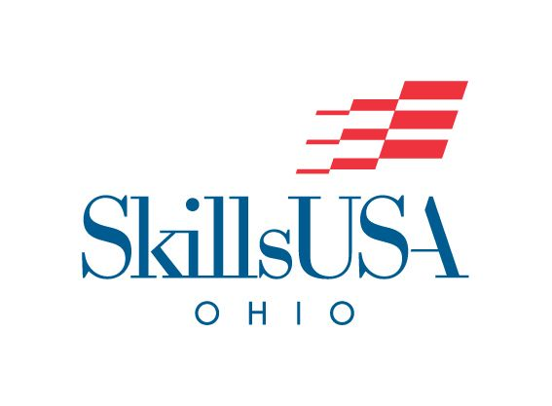

Sheet Metal

​To evaluate each competitor’s preparation for employment and to recognize outstanding students for excellence and professionalism in the field of sheet metal fabrication and installation.

On-Site/Off-Site | - On-Site
Contest Date | - ​5/5/2026
Contest Location | - Convention Center  - D-Hall
Early/Normal  Start Time | - Normal Start Time  - Registration will open at 8:00am. Please report to B-Hall Show Office for Registration. Competition will begin at 10:00am.
Contest Open/Closed | - ​Open  - Exhibit Halls do not open to observers until 12:00pm.
Eligibility &  Contest Type | - Please refer to the Program Guidelines for eligibility- https://www.ohioskillsusa.org/resources/  - Straight to State Contest (No Regional Qualifier)
Clothing | For Competition Day the Dress Code is:  Class C  For the Awards Ceremony the Dress Code is:Class A or Class J  - SkillsUSA Ohio Clothing Guide
Safety Equipment Required | - Safety glasses with side shields or goggles (Prescription glasses can be used only if they are equipped with side shields. If not, they must be covered with goggles).  - Leather Hard Sole Shoes. (Leather or Canvas athletic type shoes are not acceptable the contestant will not be allowed to compete if worn)  - Leather work gloves are recommended  - Acceptable work clothes that follow safety guidelines for working in the field of Sheet Metal
Testing | - Students should be prepared to take a written knowledge test.
Provided by Contestant  (Tool List) | Documentation  - One hard copy of a 1-page typed personal resume  Personal Tools  - 2 #2 pencils (sharpened)  - Toolbox (optional)  - Aviation Snips/Offset Snips (Contestant personal preference)  - Combination or pattern snips (optional)  - Divider (Number 18 Divider)  - 12” Minimum combination square with glass level  - Flexible steel tape measure  - Scratch Awl  - Screwdriver (Straight)  - Riveting Hammer or Setting Hammer (Contestant personal preference)  - 36” straightedge  - Drive cleat turner  - Folding Hand Tongs  - Hand-held calculator  - Center Punch  - Marking Pen (Sharpie)  - Scratch Gauges  - 6” or 12” architectural scale (to measure a field drawing and written test)  - Additional tools as desired subject to coordinator’s approval
Contest Notes, Themes, & Deadlines | - N/A
WIFI Provided? | - No
Special Notes/Rules for All Contests | - Starting in 2024, all Skilled Trade State Contests (most leadership contests already use scenarios) will begin to add a scenario-based component.  - Wi-Fi will NOT BE AVAILABLE unless listed above. If you need WIFI access, please plan to bring a hotspot.  - All safety requirements will be heavily enforced. Competitors are to follow all safety standards and OSHA Regulations  Contestants MUST HAVE A COPY OF THEIR EMERGENCY MEDICAL FORM IN THEIR NAME BADGE AT ALL TIMES  THE FOLLOWING ITEMS ARE PROHIBITED; VIOLATION OF ANY OF THE FOLLOWING MAY RESULT IN COMPETITOR DISQUALIFICATION:  - Contact with Contest Coordinators is prohibited.  - Contact with Contest Coordinators outside of the SkillsUSA Ohio is strictly prohibited.  - Possession of smart watches and/or phones during the contest and/or in contest.  - Contact with anyone outside of the contest area once the contest begins.  - Inappropriate communication between contestants such as verbally degrading another contest.  - Cheating on any portion of the contest such as informing another contestant of the skills/test prior to competing.  - Lack of Copy Emergency Medical Form in Name Badge.
National Technical Standards | - Please refer to the 2024-2026 National Technical Standards for all contests. All standards included may be tested in any competition.  - In conjunction with National Standards, lack of understanding of State Level competition standards (this document) may result in student loss of contest.
Resume/Interview Requirement | - All SkillsUSA Ohio State Championship Contests will require a short interview component. Students should be prepared with basic job interview skills.  - All contestants must have a hard copy of a one (1) page personal resume.

